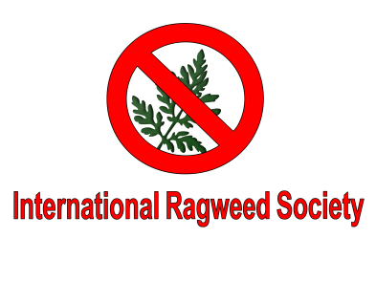
IRS SCIENTIFIC EVENTS DURING ICA 2018
In the framework of the next ICA-2018 Parma (3-7 September 2018) our Society is organizing in cooperation with ICA 2018 a “2days ragweed package”, which includes:
- Monday 3 of September:
  - Ragweed workshop (morning) on the following preliminar topics: Ambrosia impact on health; How to recognize the different Ambrosia species; How to distinguish Ambrosia pollen from other similar pollen; How to manage the plants; Ophraella recognition, biology, impact on pollen production, health costs and economy.
  - The scientific sessions included IRS session (afternoon)
  - Opening Ceremony and Welcome Reception
- Tuesday 4 of September:
  - Scientific sessions included IRS sessions (morning)
  - Scientific session (afternoon)
FEES, VAT 22% excluded, VAT at current rate
- Early registration: within May 15th 2018- €220,00 excluding VAT
- Late Registration: within June 15th 2018 - € 280,00 excluding VAT

Special IRS “2days ragweed package” registration fee includes: participation in the scientific sessions as per program above, Opening Ceremony and Welcome reception, light sandwich lunch on Monday and lunch on Tuesday as per ICA program, Abstract book and Final Program of the congress and materials.
VAT EXEMPTION please refer to www.ica2018.eu at registration page.
REGISTRATION: to register please contact ica2018registrations@mvcongressi.it
For the participation to the entire ICA congress, the IRS members have preferential fees. Please consult www.ICA2018.eu
Hoping to see you there!

